PROJECT ON OLA SERVICE REVIEWS


Project Overview:
This dataset captures end-to-end operations of a ride-hailing platform at the individual booking level. It includes temporal, geographic, and vehicle-related attributes to analyse ride demand, fleet utilization, and operational efficiency. Booking status and cancellation fields enable identification of service breakdowns and process gaps. Turnaround time metrics support evaluation of service responsiveness. Revenue-related variables allow assessment of monetization patterns and payment preferences. Customer and driver ratings provide insights into service quality and experience alignment. Rating gap analysis helps identify perception mismatches and training needs. Vehicle-type information supports segment-wise performance comparison. Visual assets enhance dashboard interpretability. Overall, the dataset enables KPI-driven analysis for operational, financial, and experience optimization.

Problems:
The ride-hailing business requires a consolidated analytical view to understand demand patterns, operational bottlenecks, revenue drivers, and service quality gaps across vehicles, customers, and drivers. Fragmented visibility into bookings, cancellations, turnaround times, and rating mismatches limits data-driven decision-making for improving efficiency, customer satisfaction, and driver performance.

Objectives:
- Analyse ride volume trends to understand demand behaviour over time.
- Evaluate booking outcomes to identify cancellation and failure drivers.
- Assess vehicle-wise performance in terms of distance, revenue, and ratings.
- Measure operational efficiency using turnaround time metrics.
- Analyse payment method preferences and revenue contribution.
- Identify high-value customers based on booking value.
- Examine driver and customer rating distributions for quality control.
- Quantify rating gaps to assess experience alignment.
- Detect service bottlenecks impacting completion rates.
- Enable KPI-driven insights through interactive dashboards for business decisions.

Analyses:
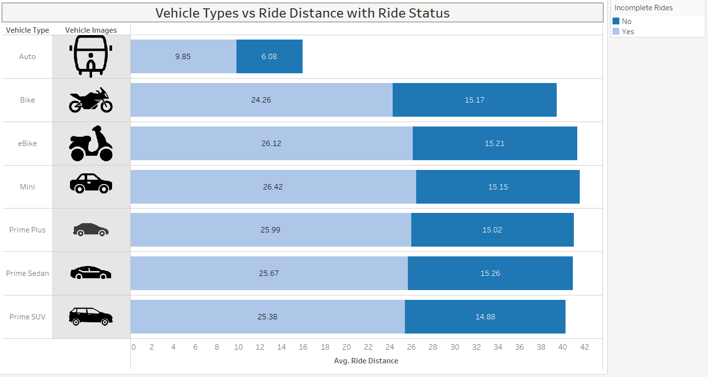
- Completed rides are consistently longer
  - For every vehicle type, completed rides (“No” incomplete) have higher average distance than incomplete rides.
  - Reason: Longer trips justify the effort and fare, so drivers are more willing to complete them.
- Incomplete rides are mostly short-distance trips
  - Incomplete rides cluster around ~25–26 km (Bike, eBike, Mini, Prime categories).
  - Reason: Short or low-value trips are more likely to be cancelled due to wait time, traffic, or low driver incentive.
- Auto shows the shortest average distance
  - Auto has the lowest distances for both completed and incomplete rides.
  - Reason: Autos are primarily used for short intra-city trips with high cancellation sensitivity.
- Premium vehicles complete longer trips
  - Prime Sedan, Prime Plus, and Prime SUV show high completed-ride distances (~15 km).
  - Reason: Higher fares motivate drivers to accept and complete longer rides.

- Bike & eBike show higher incomplete distances
  - Bikes and eBikes have relatively long incomplete ride distances.
  - Reason: Long bike trips are uncomfortable or inefficient, increasing mid-journey cancellations.

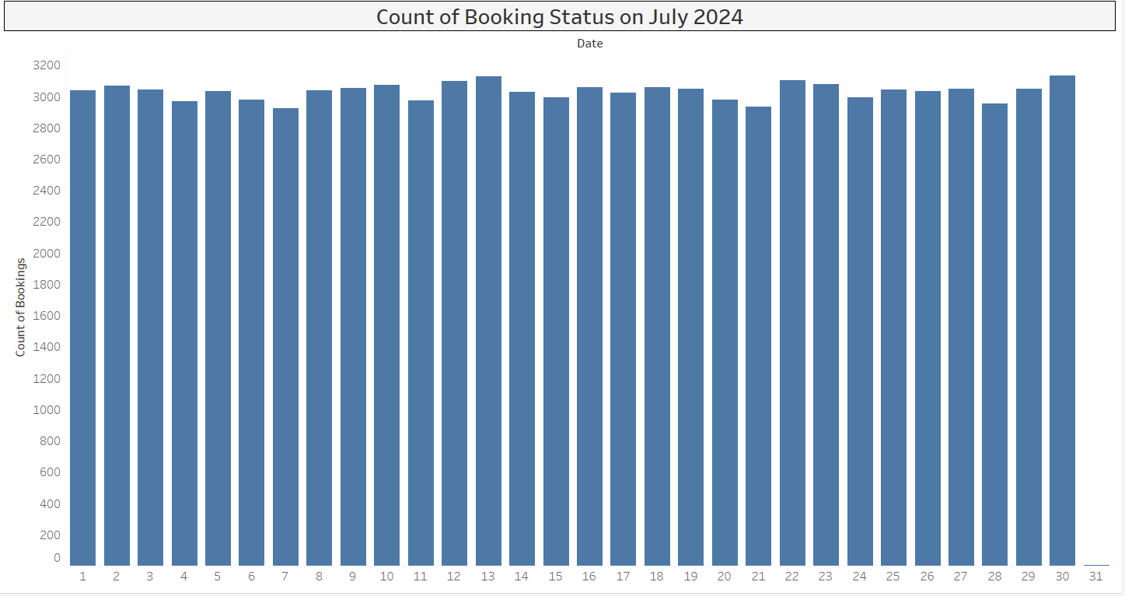
- Bookings are stable across the month
  - Daily bookings stay around ~2,950 to 3,150.
  - Reason: Demand for ride-hailing is consistent and routine-driven.
- No sharp spikes or drops
  - There are no extreme highs or lows on any specific date.
  - Reason: No major disruptions, festivals, or supply shocks during the month.
- Slight increase towards month-end
  - Bookings are marginally higher in the last week of July.
  - Reason: Month-end travel, salary credit cycle, and higher discretionary movement.
- Mid-month dip visible
  - A small drop appears around days 6–7 and 20–21.
  - Reason: Typical weekday slowdown or short-term supply constraints.

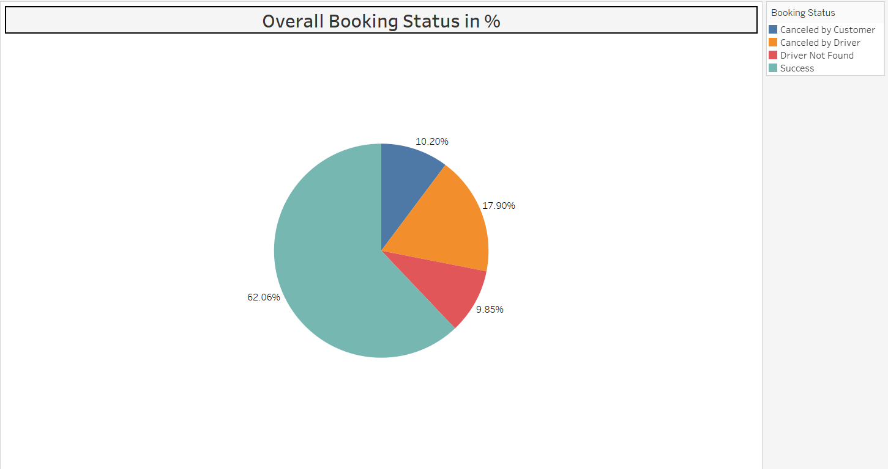
- Most rides are completed (62.06%)
  - Nearly 6 out of 10 bookings are successful.
  - Reason: Demand is strong and drivers generally accept rides.
- Driver cancellations are the biggest failure reason (17.90%)
  - This is the largest non-success segment.
  - Reason: Drivers cancel due to low incentive, long pickup distance, traffic, or multi-app usage.
- Customer cancellations are lower (10.20%)
  - Fewer customers cancel compared to drivers.
  - Reason: Customers cancel mainly due to long wait time or no driver movement.
- Driver Not Found is still significant (9.85%)
  - Almost 1 in 10 bookings fail due to no driver availability.
  - Reason: Supply-demand mismatch in certain locations or time slots.

Business Interpretation
- ~38% of bookings do not convert into completed rides, which is a major revenue leakage.
- Driver-side issues (cancellations + not found ≈ 28%) dominate failures, not customer intent.
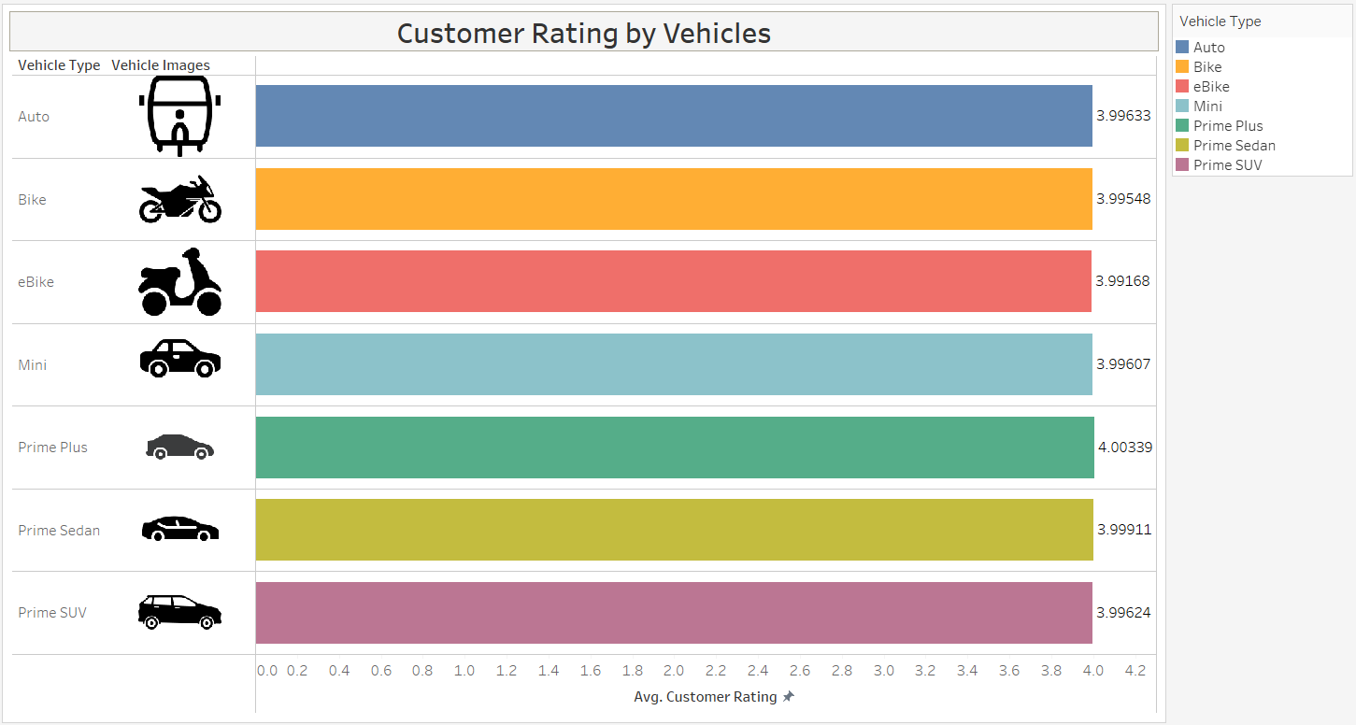
- All vehicle types are rated around 4.0
  - Ratings range narrowly from ~3.99 to ~4.00.
  - Reason: Overall service quality is consistent across categories.
- Prime Plus has the highest rating (~4.00)
  - Premium category performs slightly better.
  - Reason: Better vehicles, trained drivers, and higher customer expectations being met.
- Bike and eBike have marginally lower ratings
  - Still close to 4.0, but lowest among options.
  - Reason: Exposure to weather, safety perception, and comfort limitations.
- Auto, Mini, Prime Sedan, and Prime SUV are almost equal
  - No major quality gap between standard car categories.
  - Reason: Similar driver behaviour, ride experience, and pricing expectations.

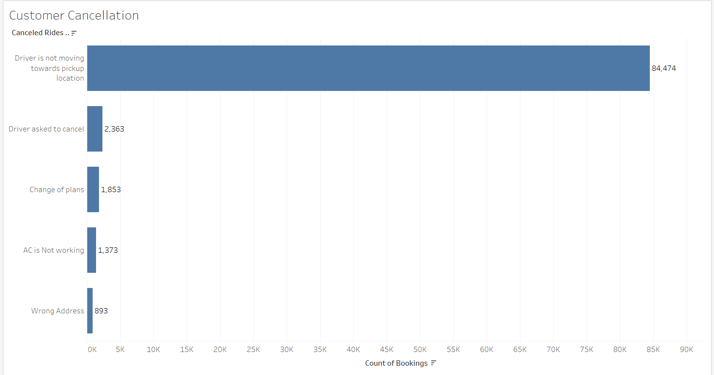
Main reason for cancellation: Most customers cancel because the driver is not moving toward the pickup location (84,474 cases). This shows a major operational issue.
- Minor reasons:
  - Driver asked to cancel (~2,363): Indicates driver-side reluctance or constraints.
  - Change of plans (~1,853): Normal customer behaviour; relatively low impact.
  - AC not working (~1,373): Service quality issue but limited in volume.
  - Wrong address (~893): Data entry or location accuracy problem, least frequent.
- Key insight:
Driver behaviour and tracking delays are the biggest cause of customer dissatisfaction, not customer intent.
- Business implication:
Improving driver assignment, movement tracking, and accountability will significantly reduce cancellations and improve customer trust.

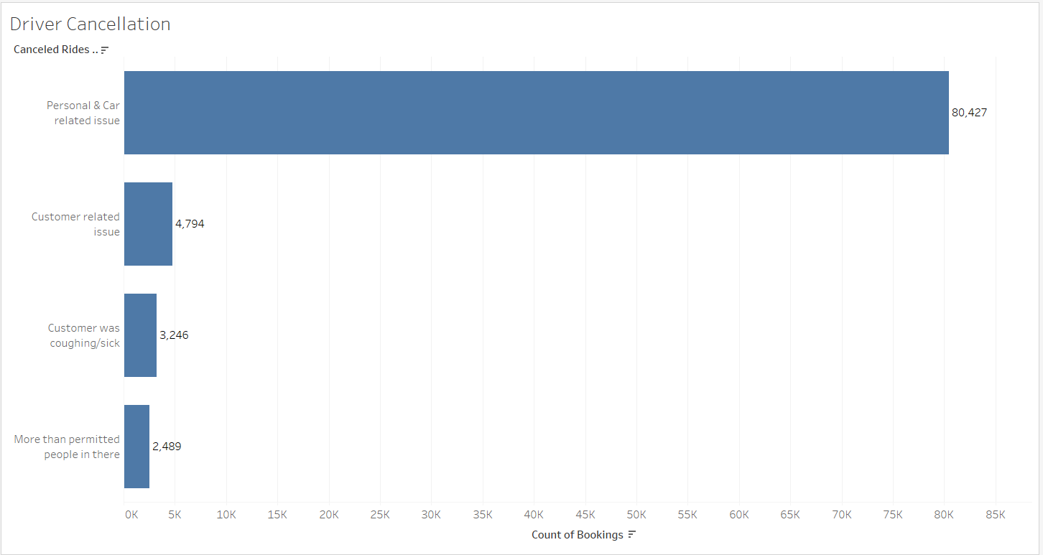
- Most driver cancellations happen due to “Personal & car-related issues.”
This means drivers are often not ready or facing vehicle problems after accepting rides.
- Customer-related issues are very small in comparison.
So, customers are not the main reason for driver cancellations.
- Health-related cancellations (customer sick) are low.
This is a safety concern, not a volume problem.
- Overcrowding in rides causes the least cancellations.
This shows rule violations are rare.
- Driver-side operational problems are the biggest reason for ride failures, not customer behaviour.

What the Company Should Do
- Improve driver readiness checks
- Reduce late driver cancellations
- Add penalties or controls for frequent cancellers
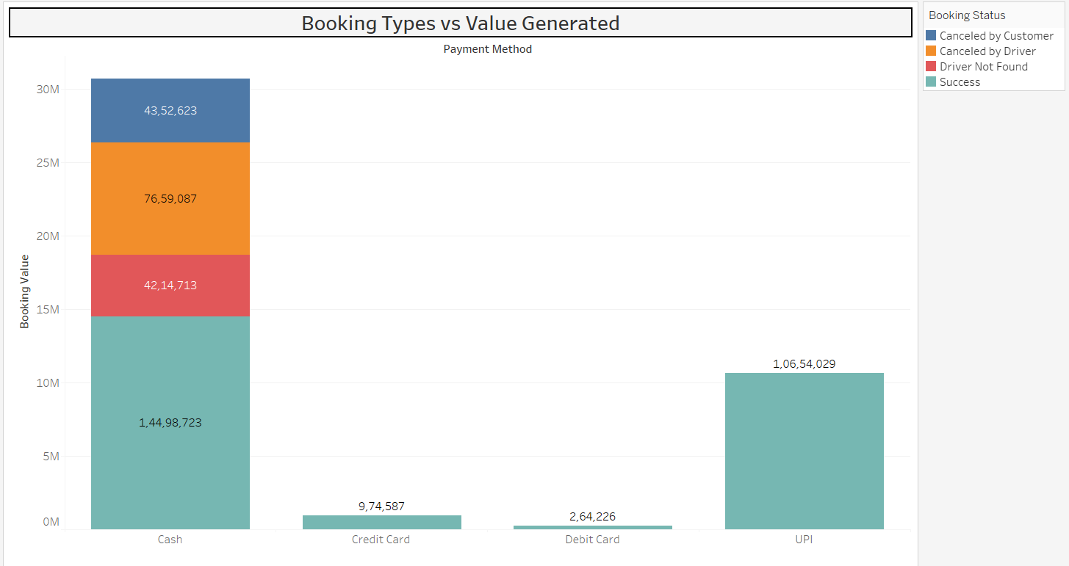
Simple Interpretations
- Cash generates the highest total booking value, but it also has the most cancellations (by both customers and drivers): Cash rides are high volume but risky.
- UPI generates high value with mostly successful bookings: UPI is more reliable and efficient.
- Credit Card and Debit Card contribute very little value: These payment methods are least used.
- Cancelled-by-driver issues are mainly seen in cash bookings: Drivers may prefer digital payments over cash.
# Digital payments (especially UPI) are more successful, while cash bookings cause higher cancellations and operational issues.

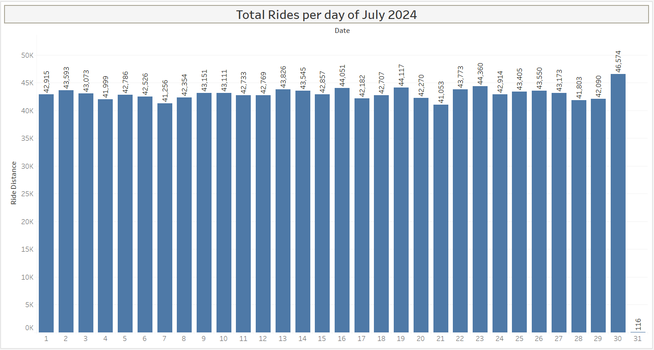
- Daily rides are very stable throughout the month (around 42K–46K rides per day).
- There are no big spikes or drops, showing consistent demand.
- A slight increase is seen toward the end of the month, with the highest rides on the last day.
- Minor ups and downs are normal and likely due to weekends or daily demand changes.

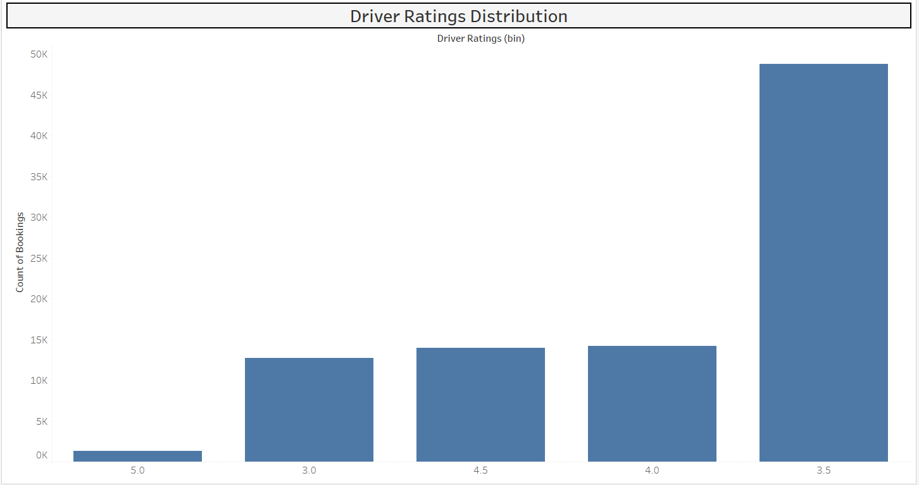
Most drivers are rated around 3.5 to 4.5 stars: This shows average to good service quality.
Very few drivers have very low or perfect (5.0) ratings: Extreme ratings are rare.
Ratings are clustered in the middle, not spread widely.
Customers tend to give safe or neutral ratings.

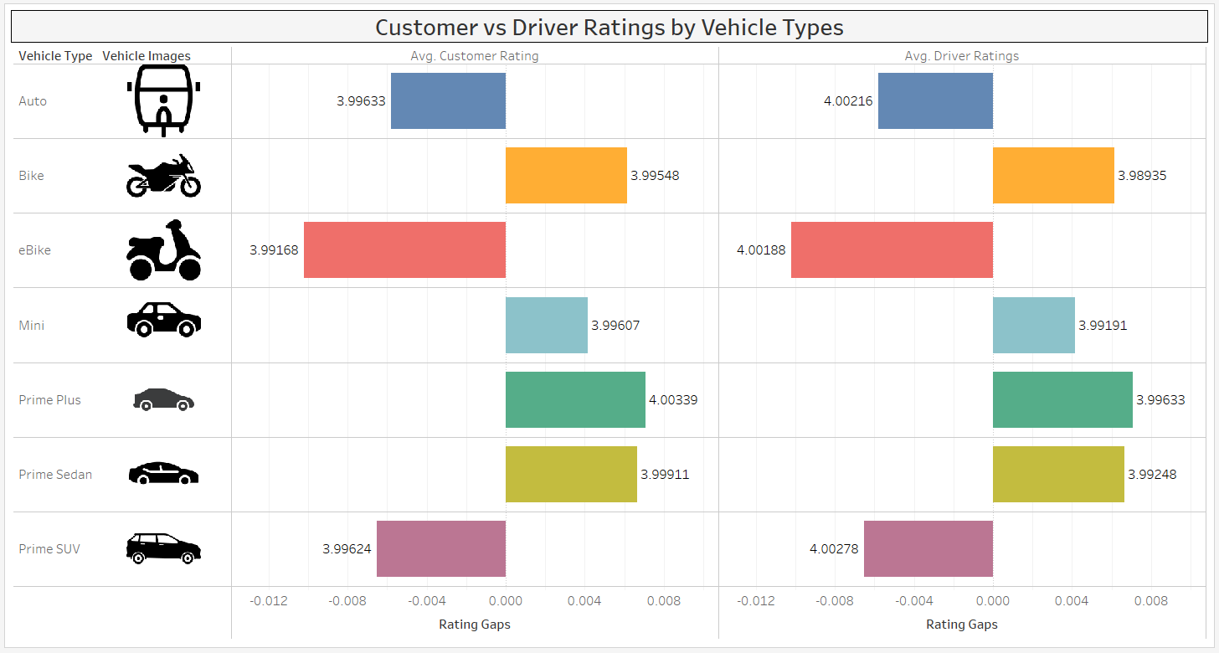
Negative gaps signal customer dissatisfaction, while positive gaps suggest driver dissatisfaction or higher effort without equal reward.

Rating Gap Interpretation
- Auto, eBike, and Prime SUV show negative rating gaps, meaning drivers rate themselves slightly higher than customers rate them.
Reason: This indicates a mild overestimation of service quality by drivers or unmet customer expectations in these segments.
- Bike, Mini, Prime Plus and Prime Sedan exhibit positive rating gaps, where customers rate the service marginally higher than drivers.
Reason: These categories may be delivering better-than-expected experiences relative to driver perception.

Streamlit Dashboard Deployment – https://app-pe9wnh65iektprcdgh2bra.streamlit.app/
Github – https://github.com/Pheonix1998

Conclusion:
From a management perspective, the analysis highlights that Ola’s core business demand is stable and resilient, but operational inefficiencies on the supply side are the primary constraint to performance improvement.
- Revenue and demand fundamentals are strong: Ride volumes remain consistent across the month, indicating predictable demand and a mature customer base. This provides a solid foundation for scaling efficiency rather than demand generation.
- High conversion loss is a critical concern: Nearly 38% of bookings do not convert into completed rides, representing significant revenue leakage. The data clearly shows that this loss is driver-driven, not customer-driven.
- Driver-side issues dominate failures: Driver cancellations and “driver not found” cases together account for the majority of unsuccessful bookings. Personal, vehicle-related, and readiness issues point to gaps in driver onboarding, monitoring, and accountability.
- Customer dissatisfaction is operational, not behavioural: Most customer cancellations occur because drivers do not move toward pickup locations. This reflects execution and tracking failures rather than lack of customer intent.
- Payment strategy impacts operational reliability: Cash bookings generate high value but are associated with higher cancellation risk, while UPI emerges as the most reliable and efficient payment method. Encouraging digital payments can directly improve completion rates.
- Service quality is consistent but perception gaps exist: Overall ratings hover around 4.0, indicating an acceptable service quality. However, negative rating gaps in Auto, eBike, and Prime SUV segments signal unmet customer expectations and a need for targeted driver training and experience improvements.
- Premium segments show better alignment: Prime categories perform well on distance, completion, and ratings, suggesting that higher incentives and clearer expectations improve outcomes.
In summary, Ola’s growth opportunity lies not in increasing demand, but in tightening driver operations, reducing cancellations, improving real-time driver accountability, and shifting customers toward digital payments. Addressing these areas can significantly enhance revenue realization, customer trust, and overall platform efficiency without major structural changes.

